Anaconda Installation Instructions

1. Jupyter Notebooks are the standard notebook style Python IDE (integrated development environment). The most common source is found in the Anaconda Environment which is prebuilt for data science and works on Windows, Mac, and Linux.
   1. To download Anaconda, navigate to <https://www.continuum.io/downloads> and select the icon for your OS.
   2. Download the Python 3.X version (recommend Graphical Installer for Mac) and install the program.
2. Once the program is installed you can open it by selecting ‘Anaconda Navigator’ in your programs list.
   1. Run the program and when it opens, select ‘Launch’ under ‘Jupyter Notebook’. (it should launch in a web browser)
   2. 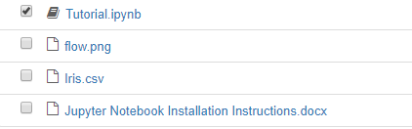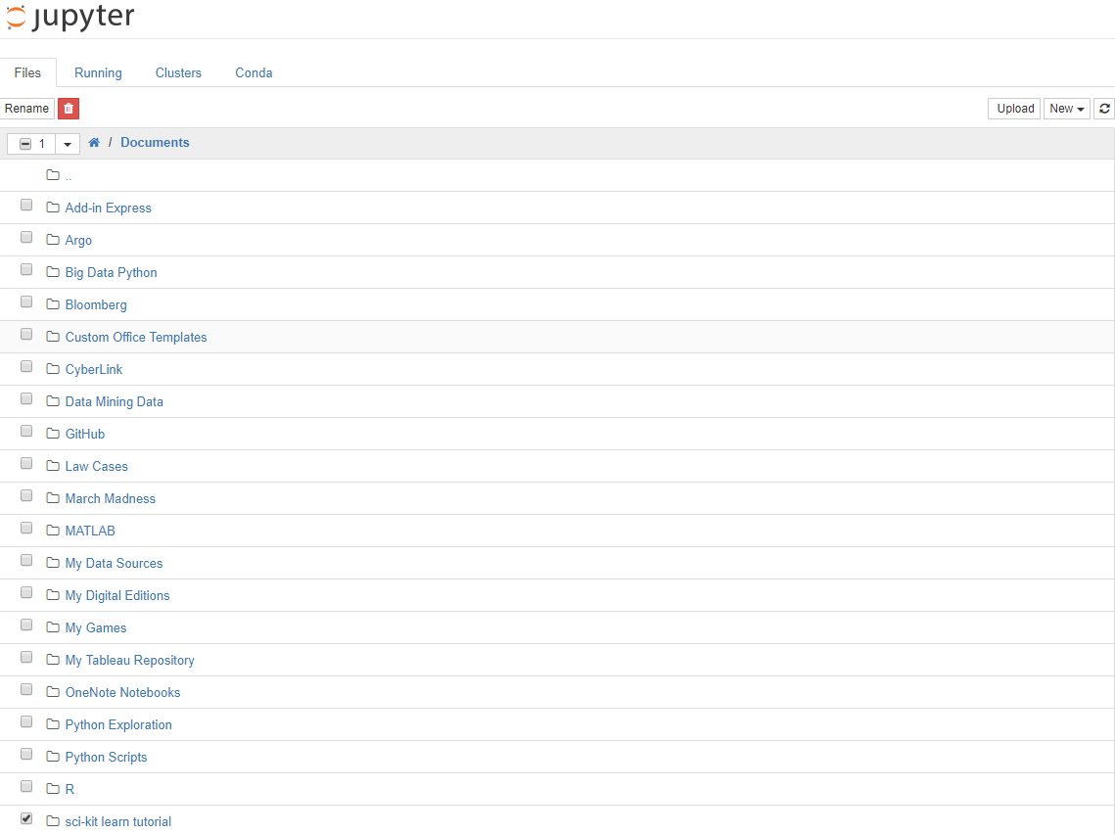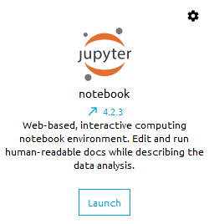Navigate to the location you saved the folder and select ‘sci-kit learn tutorial’ (you will have different folders than mine
   3. Select ‘Tutorial.ipynb’